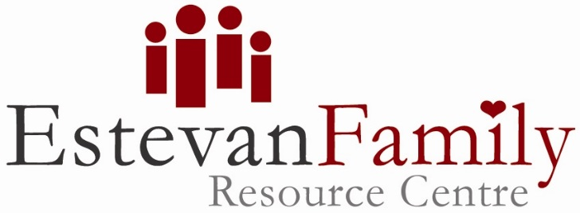
1322-7th Street
Estevan Saskatchewan, S4A 2L6
Canada
Phone 306-634-7233
Email estevanfamilycentre@sasktel.net
Web address: www.estevanfamilycentre.com

Important COVID-19 Information – Update June 1st 2021

Due to the ongoing pandemic across the world, we are doing our part and working hard to ensure we keep the Centre a safe space for families to come and connect with their little ones. As per the governments’ guidelines, everyone over the age of 24 months must wear a mask inside the building. We are asking families to support social distancing. Upon entry you will be required to complete a Covid sign in sheet, along with having a quick temperature check. Sanitizer is provided at various sites in the space and should be used accordingly. Snacks must be eaten at the designated area. Drinks may be permitted as long as they are in a sealed flask or container. We allow a maximum of 30 people on a first come, first served basis. Please keep an eye on our Facebook page for any changes or updates.

As we move into Phase One and onwards in the Saskatchewan Roadmap we will be sure to keep you updated to any guideline changes or removal of any current restrictions.

